 17th July Live Class SQL:

**Assignments:**

* **try to find out sum of balance**

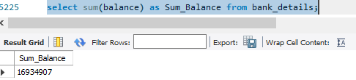

* **try to find out avarage of balance**

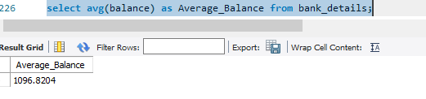

* **try to find out who is having a min balance**

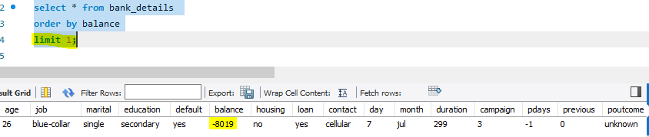

**OR  
  
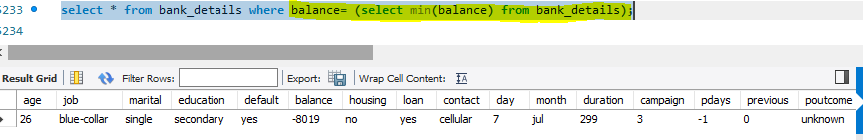**

* **try to find out who is having a maximum balance   
  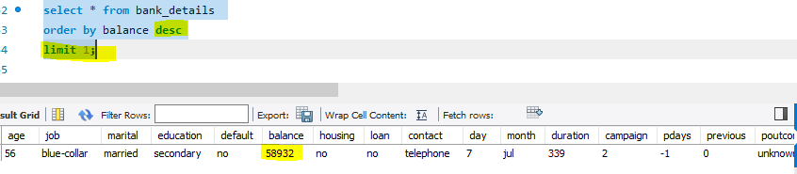**
* **try to prepare a list of all the person who is having loan**

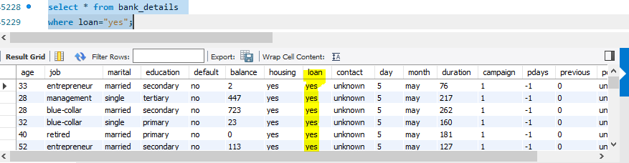

* **try to find out average balance for all the people whose job role is admin**

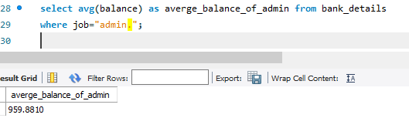

* **try to find out a record without job whose age is below 45   
  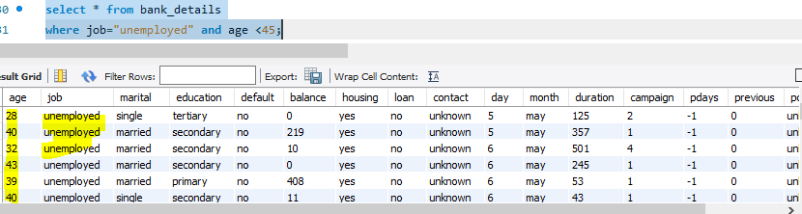**
* **try to find out a record where education is primary and person is jobless  
  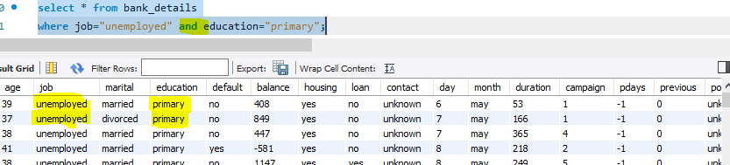**
* **try to find of a record whose bank account is having a negative balance**

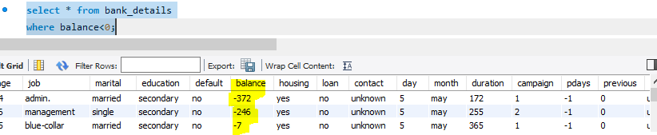

* **try to find out a record who is not having house at all along with there balance  
  